WCSD Student Advisory Council

**LET YOUR VOICE BE HEARD!**

**JOIN THE WASHOE COUNTY STUDENT ADVISORY COUNCIL TODAY!**

Student Advisory Council Meetings (*One Tuesday a Month)*:

Student Advisory Retreat: TBA

SAC Meeting Location: TBA

|  |  |  |
| --- | --- | --- |
| **Date** | **Time** | **Location** |
| August 27th | 5:00-7:00 PM |  |
| September 17th |  |
| October 15th |  |
| November 19th |  |
| December 3rd |  |
| January 14th |  |
| February 18th |  |
| March 11th |  |
| April 15th |  |
| May 13st |  |

*Please RSVP to Brose@washoeschools.net no later than 5PM on the school day prior to each meeting!

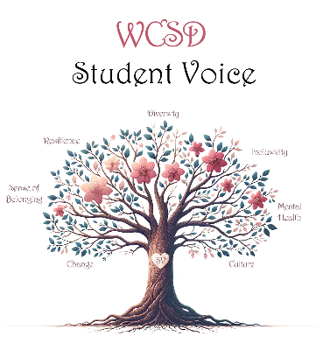

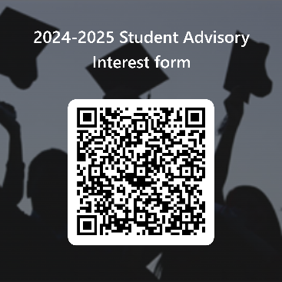

**SAC MEMBERSHIP** **NOW GIVES YOU .25 Credits OR COMMUNITY SERVICE HOURS!**

Contact Student Voice Facilitator Brad Rose at [Brose@washoeschool.net](mailto:Brose@washoeschool.net) for more information.